Retirement Finance Simulation Model

# Client: Cottons

Sun Jan 7 14:43:54 2018

Assumptions for the simulations are as follows:

* Run 10,000 scenarios.
* Demographic data
  + Husband's current age is 65.
  + Wife's current age is 67.
* Social Security data
  + Husband claims at age 70
  + Wife claims at age 66
  + Husband has the highest Social Security benefit is TRUE.
  + Expected Social Security benefit for lower earner is $ 17,580.
  + Expected SS benefit for higher earner is $ 36,444.
  + All claiming options:

|  |  |  |
| --- | --- | --- |
|  | higherEarner | lowerEarner |
| Age62 | 20820 | 17580 |
| FRA | 27612 | 23316 |
| Age70 | 36444 | 30768 |

* Portfolio parameters
  + Initial portfolio balance before annuity purchase is $ 3,940,000.
  + Equity allocations randomized from 0% to 100%.
* Market and inflation parameters
  + Annual average rate of inflation is 2%.
  + Inflation rate annual standard deviation is 1%.
  + Risk-free real return rate is 1%.
  + Equity risk premium is 4.25%.
  + Standard deviation of annual market returns is 12%.
* Immediate Annuity parameters
  + SPIA Purchase age is 65
  + Age of annuitant when payments will begin is 66.
  + Quote for annual payment before any deaths is $ 9,600.
  + Annuity is inflation-protected is TRUE.
  + Husband owns Annuity is TRUE.
  + Percent of benefit that goes to survivor is 50%.
  + SPIA payout rate is 5.36%.
  + Annuity allocation as percent of initial portfolio randomized from 30% to 40%.
* Deferred Annuity parameters
  + DIA Purchase age is 65
  + Age of annuitant when payments will begin is 80 INCORRECT.
  + Quote for annual payment before any deaths is $ 21,402.
  + Annuity is inflation-protected is TRUE.
  + Husband owns Annuity is TRUE.
  + Percent of benefit that goes to survivor is 50%.
  + SPIA payout rate is 5.36% INCORRECT.
  + Annuity allocation as percent of initial portfolio randomized from 30% to 40% INCORRECT.
* Spending parameters
  + Expected spending year one of retirement randomized from $ 216,000 to $ 240,000.
  + Percent expense decline after death of first spouse is 63%.
  + Expenses typically decline 0% annually throughout retirement.
* HECM Line of Credit
  + Home apprecation rate is 0% annually.
  + Initial HECM Line of Credit available is $ 0
  + Initial Reverse Mortgage Balance is $ 0
  + Home Market Value (no real annual growth assumed) is $ 1,200,000
  + Mean long term return for 1-yr Libor= 2% with standard deviation= 1%
  + HECM line of credit's maximum lifetime interest rate cap 10.34%
  + HECM line of credit's margin added to Libor Index for variable rate loan 3%
  + HECM line of credit's Monthly Insurance Premium percentage 1.25%

# PARAMETER SIMULATIONS

Life expectancies for husband and wife are plotted below.

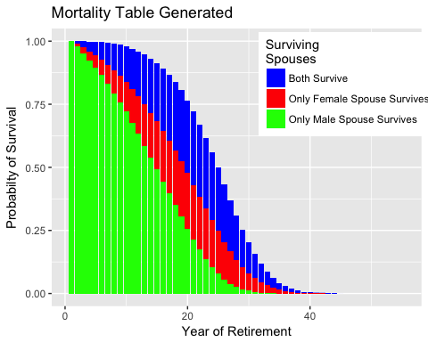

## .Primitive("return")

The following annual market returns were simulated.

## Warning: Removed 54 rows containing non-finite values (stat_bin).

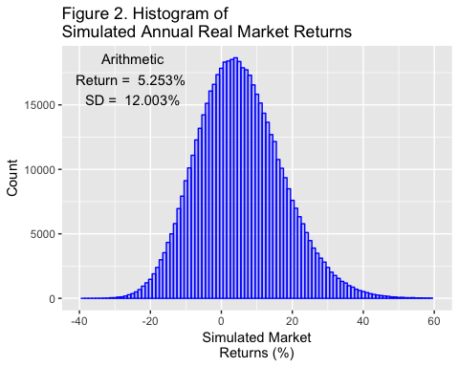

Arithmetic Mean of Simulated Annual Returns = 5.253%.

Standard Deviation of Simulated Annual Returns = 12.003%.

The following simulated annual inflation rate were simulated:

## Warning: Removed 37 rows containing non-finite values (stat_bin).

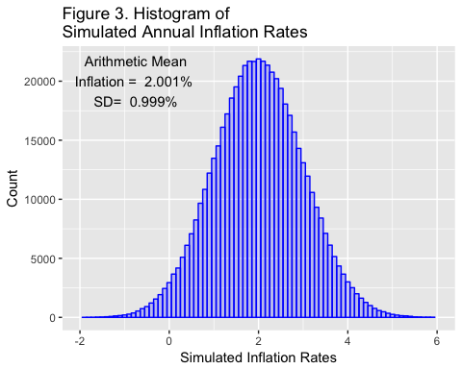 * Arithmetic Mean of Simulated Inflation Rates = 2.001%.

* Standard Deviation of Simulated Annual Inflation Rates = 0.999%.

The graphs that follow are intended to show the range of inputs used by the simulation model (for example, the range of spending tested) and the distributions of the input parameters (for example, life expectancy follows a Gompertz distribution, while spending parameters are randomized with a uniform distribution.)

The following chart shows the number of scenarios simulated at each level of annuity allocation. The *x*-axis shows the range of annuity allocations simulated.

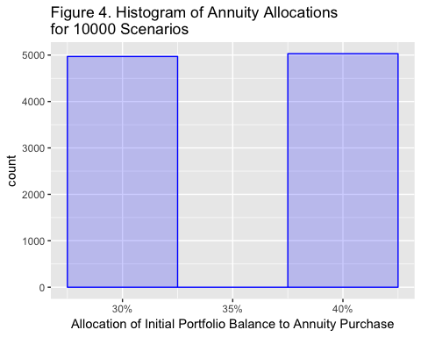

The following chart shows the number of scenarios simulated at each level of equity allocation. The *x*-axis shows the range of equity allocations simulated.

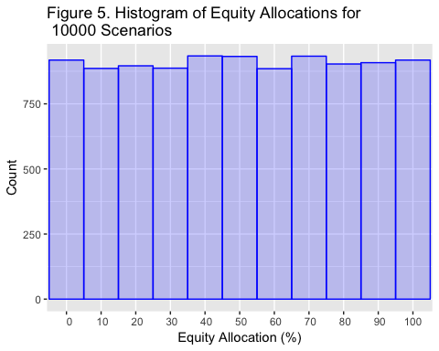 # Results of Simulations

* Statistics For Underfunded Scenarios
* 120 scenarios with unmet spending or 1.2%
* Some failed scenarios were almost completely funded, while some funded scenarios were just barely funded. These scenarios fall within the margin of error.
* Percent of scenarios that funded less than 95% of years 1.02%
* Percent of scenarios with 95% to 105% of years funded
* Percent of scenarios with more than 105% funding
* Number of years with unmet spending 600
* Mean years with unmet spending when spending not met 5
* Depleted portfolios 1.2 %
* Scenarios depleting HECM Line of Credit 0 or 0%

The previous charts showed the distribution and ranges of key randomized inputs to the simulation model including spending, equity allocation, annuity allocation and stochastic life expectancies. The following charts provide a summary of the simulation model's output for those scenarios and years that were underfunded in the simulation.

Following is a histogram showing spending amounts (and the range of spending along the *x*- axis) for the first year of each retirement scenario.

This histogram shows the cumulative ratio of underfunded simulated years by the amount of spending for the first year of retirement. The right-most column, for example, shows that 100% of 120 unfunded years had spending in the first year of retirement of $ 240,000 or less. The column to its left shows that about 80% of all 120 unfunded years had spending in the first year of retirement of $ 237,600 or less.

About half of the 120 underfunded years in this simulation could have been funded by spending less than $ 235,200 from the beginning of retirement.

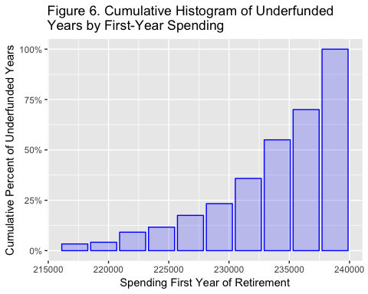

Following is a histogram showing the equity allocation for underfunded scenarios (an underfunded scenario had at least one underfunded year).

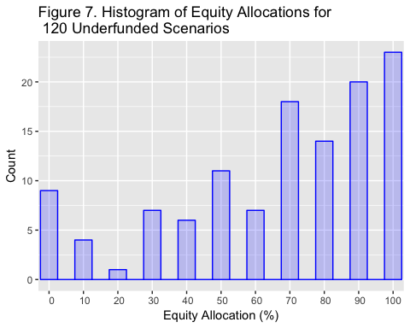

Following is a histogram showing the equity allocation for all underfunded *years*.

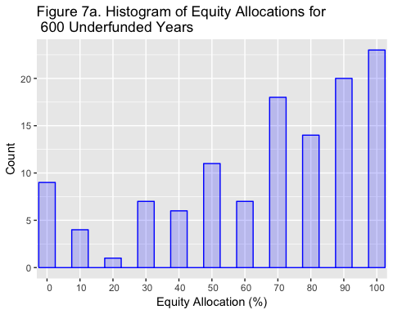

Following is a histogram of 99 %-ile terminal net worth (portfolio value plus home equity at death of the second spouse). The largest 1% of terminal net worth values are excluded because they are highly unlikely and distort the graph.

## `stat_bin()` using `bins = 30`. Pick better value with `binwidth`.

## Warning: Removed 500 rows containing non-finite values (stat_bin).

## Warning: Removed 1 rows containing missing values (geom_bar).

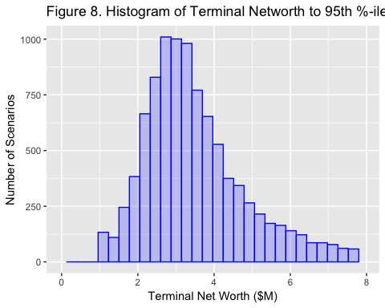

* Median Terminal Net Worth = $ 3,310,417.
* Mean Terminal Net Worth = $ 3,907,447.
* About two-thirds of Terminal Net Worth values fell between $ 1,455,667 and $ 6,359,226.
* About 95% of terminal portfolio values fell between $ 0 and $ 8,811,006.

The following graph shows the percent of years that were funded for the 120 *scenarios* that were underfunded, i.e., those scenarios with less than 100% funded years. Leftmost columns show the number of scenarios that failed early in retirement. Rightmost columns show the number of scenarios that were nearly completely funded.

Rightmost columns may fall within the margin of error and possibly should be considered successful scenarios. In this simulation, 18 or 15% of underfunded scenarios were at least 95% funded.

## Warning: Removed 500 rows containing non-finite values (stat_bin).

## Warning: Removed 13 rows containing missing values (geom_bar).

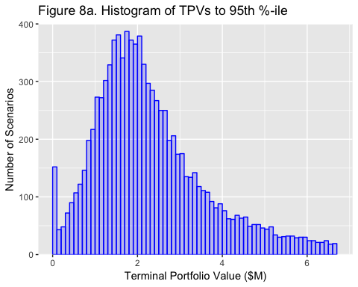

Median terminal portfolio value is $ 2,110,417

## Warning: Removed 71 rows containing missing values (geom_path).

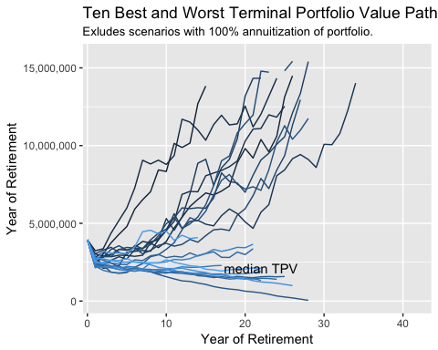

The chart above shows the ten portfolio balance paths with the highest TPV, the ten paths with the earliest portfolio depletion and the path with the median Terminal Portfolio Value.

The best paths are highly improbable and not critical in the sense that if your portfolio did take one of those paths the outcomes would be wonderful. The worst paths are also highly improbable but should be given more consideration because, while best path outcomes would be wonderful, worst path outcomes would destroy the retirement plan. A good plan will eliminate these worst-case outcomes.

Though this graph shows 21 paths, the simulation actually generated 10000 hypothetical paths. Also note that the graph lines end when the last spouse dies.

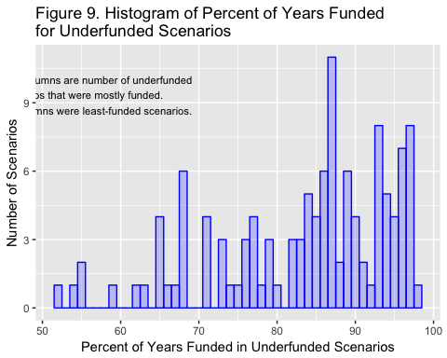 The following graph shows the number of years of retirement for which spending demand (consumption) was *not* met.

The following chart shows terminal home equity for all scenarios. If a HECM reverse mortgage is available, home equity can become negative but this is non-recourse debt and will not lower the household's terminal net worth.

## `stat_bin()` using `bins = 30`. Pick better value with `binwidth`.

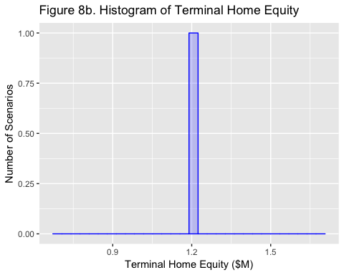

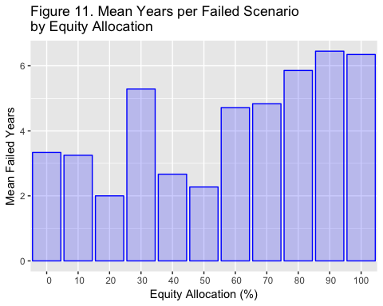 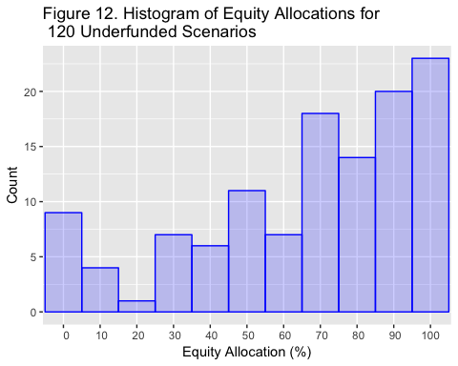

The following charts summarize a single, user-selected scenario. The black line shows consumption demanded. The colored areas indicate the source for funding that consumption. Underfunded years will show that funding sources did not achiev demanded consumption.

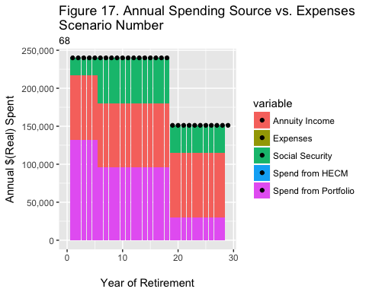

## Warning: Removed 30 rows containing missing values (position_stack).

